REMEMBER
Michelle Henry
ART GALLERY on Darling 1 – 6 November 2022

1 | 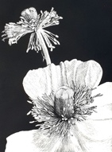 | You the dancer and I the dreamer | 2022 | Scratchbord | 12.7 x 17.8cm (image size)  26.5 x 33cm (frame size) | $320
2 | 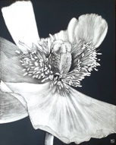 | Let her finish her dance | 2022 | Scratchbord | 20.3 x 25.4cm  (image size) 34 x 40cm (frame size) | $500
3 | 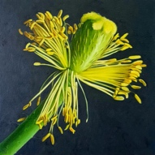 | Music, when soft voices die, vibrates in the memory | 2022 | Oil on Canvas | 40 x 40cm | $850
4 | 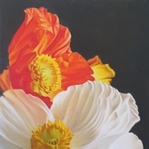 | I summon up the remembrance of things past | 2022 | Oil on Canvas | 40 x 40cm | $850
5 | 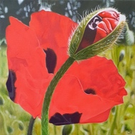 | Flesh of her flesh they were | 2022 | Oil on Canvas | 40 x 40cm | $850
6 | 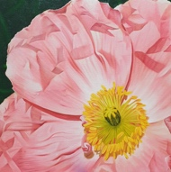 | Better by far you should forget and smile | 2022 | Oil on Canvas | 40 x 40cm | $850
7 | 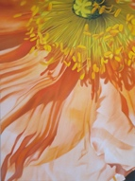 | Down in the flood of remembrance, I weep | 2022 | Oil on Canvas | 40.6 × 60.9cm | $1250
8 | 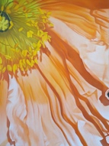 | The blood of innocence has left no stain | 2022 | Oil on Canvas | 40.6 × 60.9cm | $1250
9 | 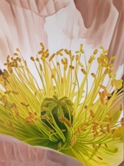 | How could I bear a crown of gold? | 2022 | Oil on Canvas | 40.6 × 60.9cm | $1250
10 | 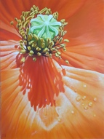 | It's only right that she live in abundance | 2022 | Oil on Canvas | 40.6 × 60.9cm | $1250
11 | 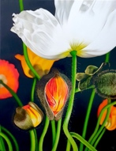 | Some are Born to sweet Delight. Some are Born to Endless Night | 2022 | Oil on Linen | 71.1 × 91.4cm | $1900
12 | 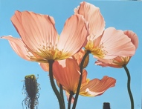 | Remember the sky that you were born under | 2022 | Oil on Linen | 91.4 × 71.1cm | $1900
13 | 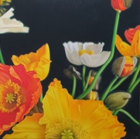 | And afterwards remember, do not grieve | 2022 | Oil on Canvas | 91.4 × 91.4cm | $2200
14 | 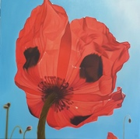 | A dawn whereto I grope In trembling faith and hope | 2021 | Oil on polyester | 90 x 90cm  (unframed) | $2200

